If you have enjoyed your time at Blackland Farm
why not join

THE FRIENDS OF BLACKLAND FARM

We are a support group, started many years ago,
by folk who wished to remain in touch and give service
to a much loved camp site

Friends arrange several annual gatherings at
Blackland Farm
with opportunities to give service, socialise and raise funds.
At other times, Friends give service when needed,
such as at Section days/weekends
serving in the shop at peak times.

Full details in our Newsletter and on our Website.
Do join us and share the fun.

Just complete the application form attached and send to:

The Treasurer
88 Ederline Avenue
Norbury
London SW16 4SA

OR Leave at the Blackland site office

See our website for dates for your diary!”

www.blacklandfarm.org

Application to Join

I wish to become a FRIEND OF BLACKLAND FARM
and enclose a subscription of: £ ___________

Payment may be made as follows:
1. Standing order to
Natwest Bank plc
Sort Code 60-01-21
Account No. 57114323
Name of Account: Friends of Blackland Farm
2. By direct payment from your bank to the above
Please use your name as a reference
3. By cheque (payable to Friends of Blackland Farm)
4. By cash – not via the post, please
(Minimum Annual Subscription £15.00)

PLEASE COMPLETE YOUR PERSONAL DETAILS OVERLEAF

PERSONAL DETAILS

Title: _______________________________

Forename: _______________________________

Surname: _______________________________

Address:

_________________________________________

_________________________________________

_________________________________________

_________________________________________

Telephone Number: _____________________

Email (if applicable) _____________________

Signed _______________________________

Date _______________________________

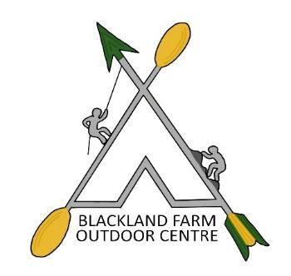

FRIENDS OF BLACKLAND FARM

Had a good time at
BLACKLAND FARM?

Why not put something back
and enjoy yourselves
at the same time?

